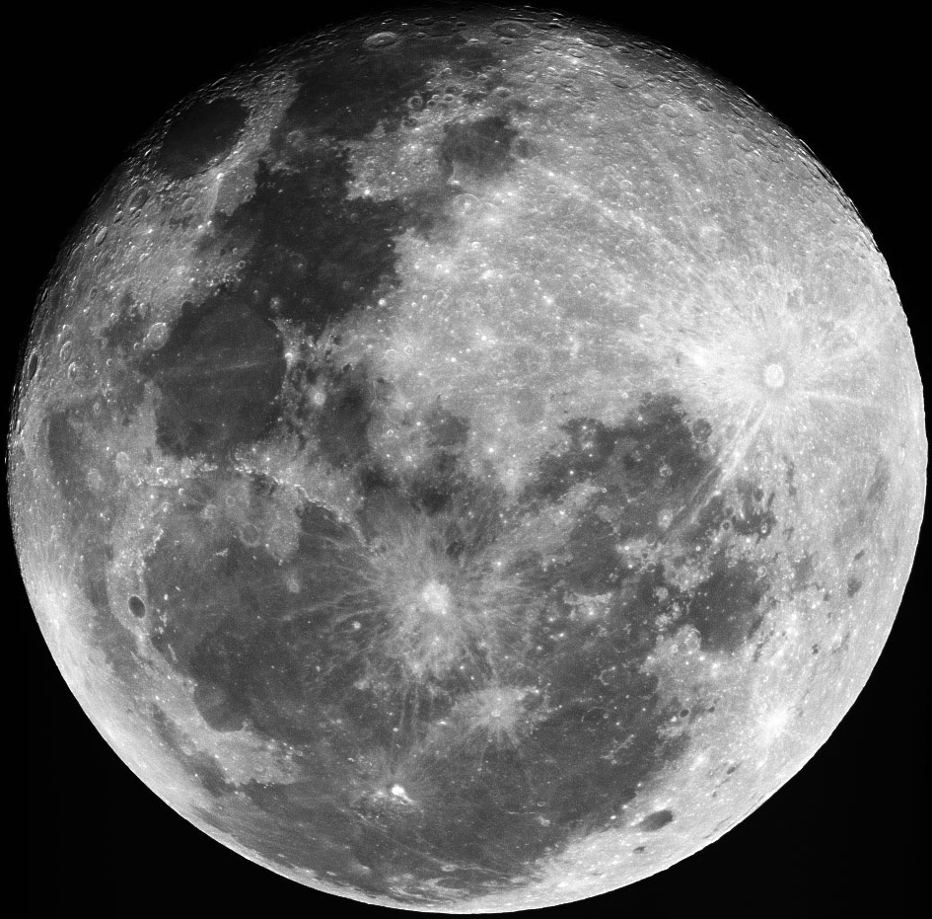
StarMessage
ScreenSaver
Installation Disk
Existing customers should request
a free activation code from
www.StarMessage.gr/lostreg.html

This document allows you to create a cover card for the StarMessage jewel box

This document contadins 2 pages.
If your printer can print on both sides of the pager, please print in that way.
(you can do that from the print options of Microsoft Word)

The image should print in dimensions of 12cm X 12cm
Cut the image at its border.
It should fit in the cover of the CD jewel box.

The opposite side of the paper contains information about the customer and the buyer (if it is a gift)
Please fill in this information.

Customer Name:

Email:

Activation code:

This is a gift from....

Name:

Email:

For registration support please contact
info@starmessage.gr
also including the information above

